Visualization of COVID-19 infected populace and self-isolated cases by municipalities/cities in Serbia

Date, Region and Domain
- April 7, 2020
- Serbia
- Health

Research Questions
- Which are the top 20 municipalities/cities in Serbia with the highest COVID-19 infected cases to population ratio?
- Which are the top 20 municipalities/cities in Serbia with the highest COVID-19 self-isolated cases to population ratio?
- Which are the top 20 municipalities/cities in Serbia with the highest COVID-19 infected cases to self-isolated cases ratio?

Data sources
- Population estimates by municipalities/cities 2018
https://publikacije.stat.gov.rs/G2019/Xls/G201913046.xlsx
- Number of COVID-19 infected cases by municipalities/cities
https://covid19.data.gov.rs/
- Number of COVID-19 self-isolated cases by municipalities/cities
https://covid19.data.gov.rs/self_isolation

Visualization
- Top 20 municipalities/cities in Serbia with the highest COVID-19 infected cases to population ratio
- Top 20 municipalities/cities in Serbia with the highest COVID-19 self-isolated cases to population ratio
- Top 20 municipalities/cities in Serbia with the highest COVID-19 infected cases to self-isolated cases ratio

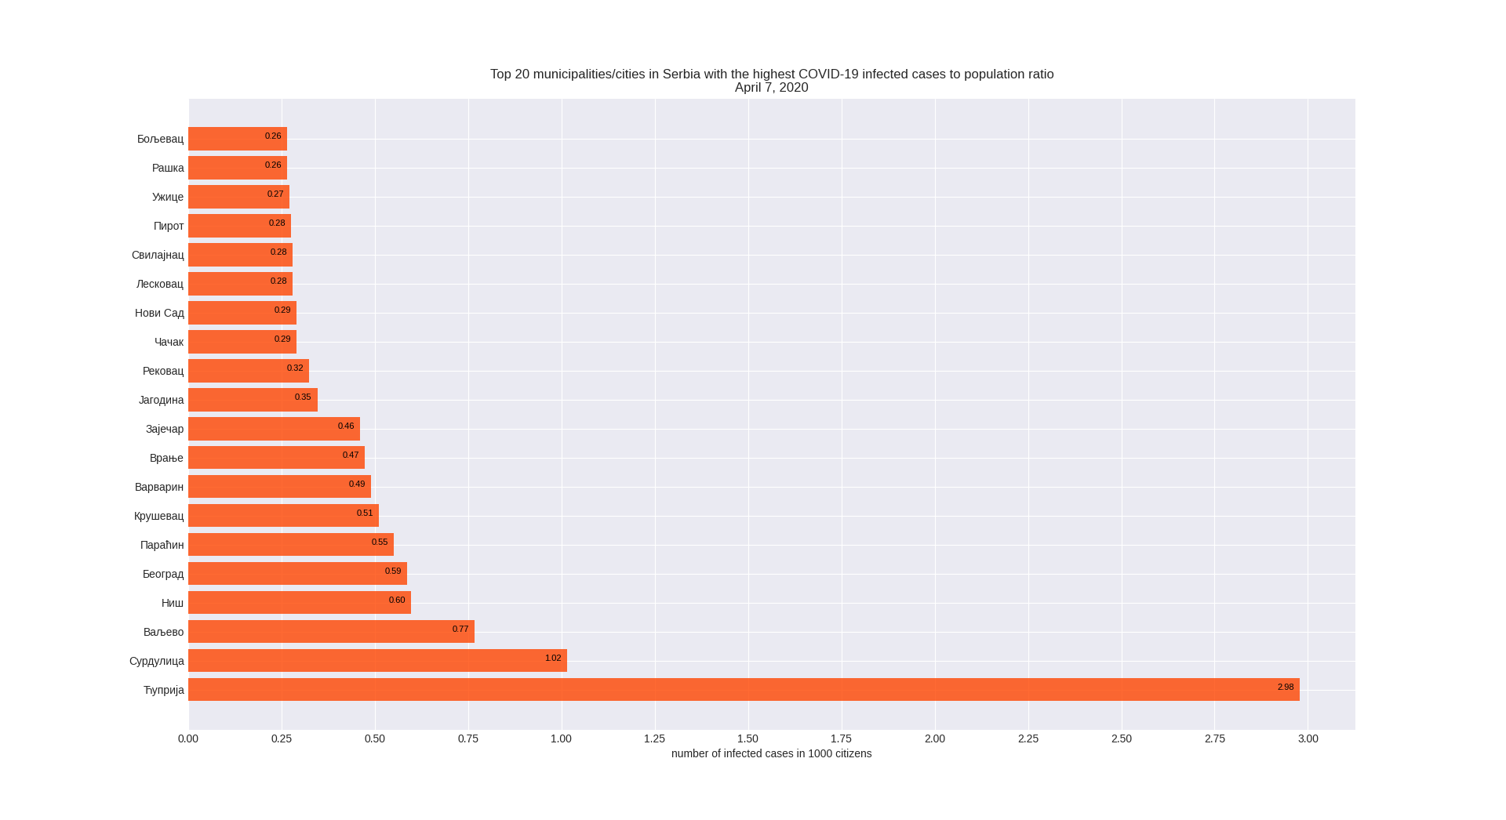
Chart 1
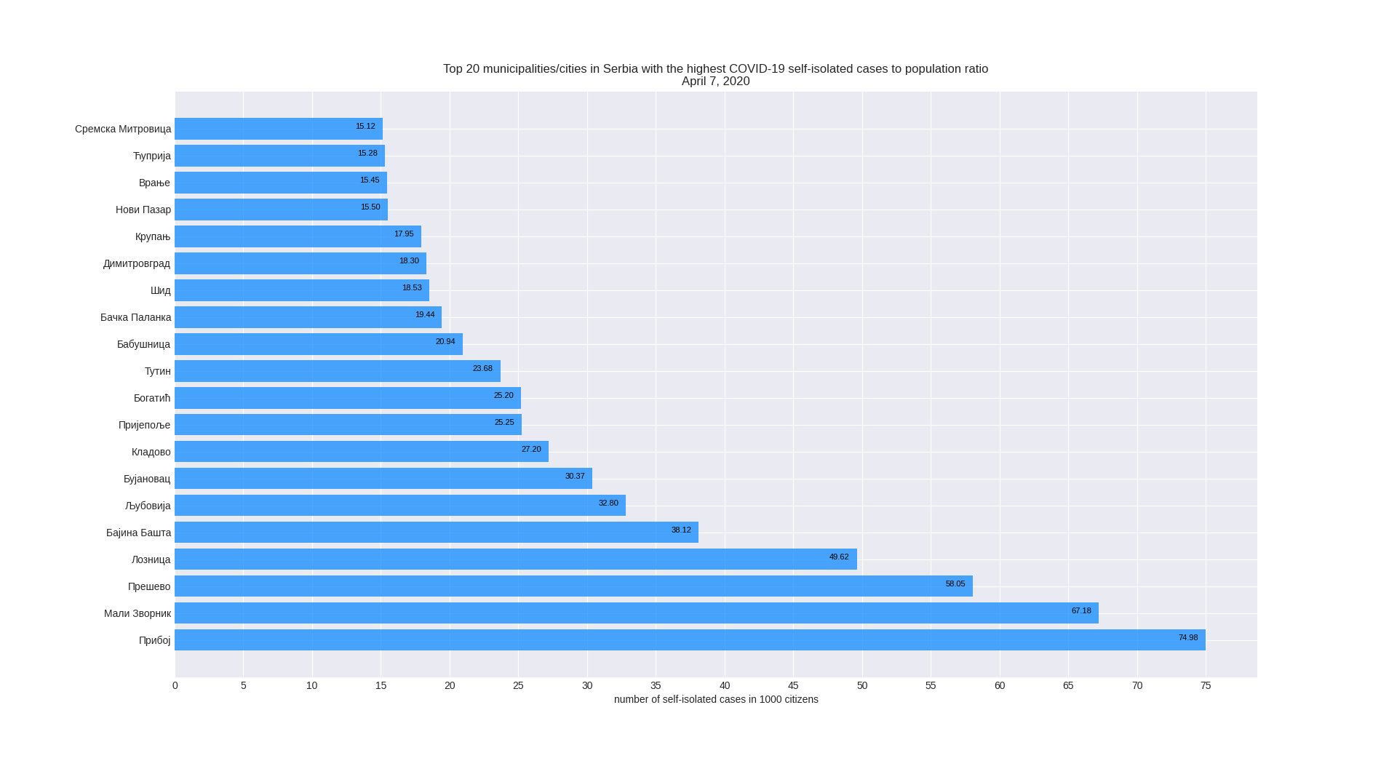
Chart 2

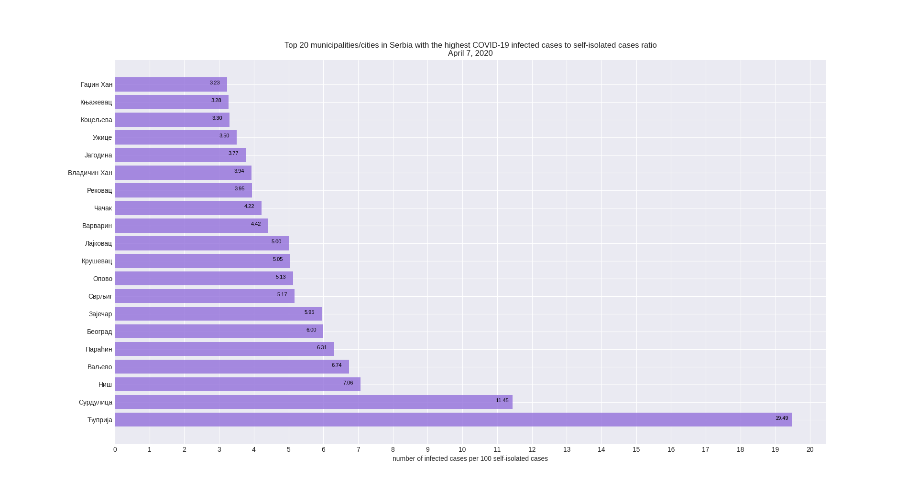
Chart 3

Discussion
The goal of visualization is to answer the research questions. Data visualization presents the difference between municipalities/cities in Serbia by different criteria. The first criterion is the number of infected cases of coronavirus to the population of the municipality/city, the second criterion is the number of cases of self-isolation from the coronavirus in ratio to the population of the municipality/city and the last criterion is the number of infected cases of the coronavirus in ratio to the number of self-isolated cases.
The municipality/city population data represent the population estimate for 2018 according to the Statistical Office of the Republic of Serbia. Due to the unavailability of accurate and complete data, the province of Kosovo and Metohija was omitted. Data on infected cases of coronavirus were downloaded from the website of the Government of the Republic of Serbia with the original source of the Institute of Public Health of Serbia "Milan Jovanovic Batut", while the number of self-isolated cases was taken from the website of the Government of the Republic of Serbia with the original source of the Ministry of Interior of the Republic of Serbia.
The first chart indicates that the municipality of Ćuprija has the highest number of infected cases in terms of population, in every 1000 citizens there are 3 infected coronavirus cases, followed by the municipality of Surdulica, which has one in every 1000 citizens, although the city of Belgrade has the highest number of infected citizens its on 5th place relative to the population. The city of Kruševac has one infected in every 2000 citizens.
The second graph indicates that majority of small municipalities such as Priboj, Mali Zvornik and Preševo have the most self-isolated cases in terms of population. The municipality of Ćuprija, which by far has the highest number of infected people, is ranked 19th, with 15 cases of self-isolation in every 1000 citizens
The third graph shows the relation between the number of infected and self-isolated cases. The City of Niš is ranked as 3rd municipalities/cities which have 7 infected cases for every 100 self-isolated cases. Most of the first 10 municipalities/cities are the same as in the first chart, both charts show the number of infected cases, but with the different criteria. This leads to the conclusion that the population and the number of self-isolated cases tend to grow/decline together.

Corona virus disease 2019 – corona viruses cause respiratory tract infections that can range from mild to lethal
Self-isolation - home quarantine for 14 to 28 days

